**Page.No.:**

**A PYTHON PROGRAM TO IMPLEMENT K-MEANS MODEL**

**Ex.No.:**

**Date of Experiment:**

**Date of Submission:**

**AIM:-**

To implement a python program using a K-Means Algorithm in an model.

**ALGORITHM:-**

Step1: Import all the other necessary libraries(numpy as np, matplotlib.pyplot as plt and sklearn.tree,pandas as pd and seaborn as sns).

Step2: Select the number K to decide the number of clusters.

Step3: Select random K points or centroids. (It can be other from the input dataset).

Step4: Assign each data point to their closest centroid, which will form the predefined K clusters.

Step5: Calculate the variance and place a new centroid of each cluster.

Step6: Repeat the fourth steps, which means reassign each datapoint to the new closest centroid of each cluster.

Step7: If any reassignment occurs, then go to step-5 else go to FINISH.

Step8: Train the model and plot the graph using scatterplot() function.

**IMPLEMENTATION:-**

import numpy as np

import pandas as pd

from matplotlib import pyplot as plt

from sklearn.datasets import make_blobs

from sklearn.cluster import Kmeans

**Page.No.:**

X, y = make_blobs(n_samples=300, centers=4, cluster_std=0.60, random_state=0)

plt.scatter(X[:,0], X[:,1])

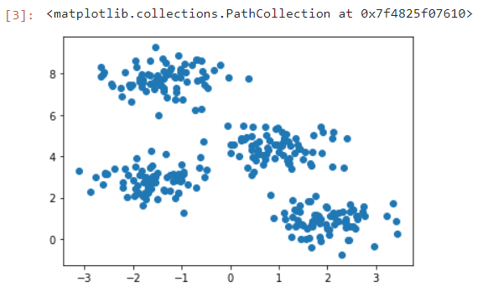

wcss = []

for i in range(1, 11):

kmeans = KMeans(n_clusters=i, init='k-means++', max_iter=300, n_init=10, random_state=0)

kmeans.fit(X)

wcss.append(kmeans.inertia_)

plt.plot(range(1, 11), wcss)

plt.title('Elbow Method')

plt.xlabel('Number of clusters')

plt.ylabel('WCSS')

plt.show()

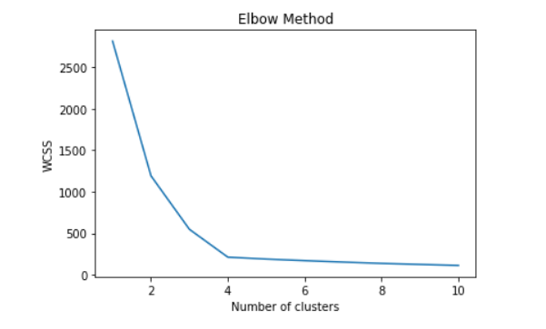

**Page.No.:**

kmeans = KMeans(n_clusters=4, init='k-means++', max_iter=300, n_init=10, random_state=0)

pred_y = kmeans.fit_predict(X)

plt.scatter(X[:,0], X[:,1])

plt.scatter(kmeans.cluster_centers_[:, 0], kmeans.cluster_centers_[:, 1], s=300, c='red')

plt.show()

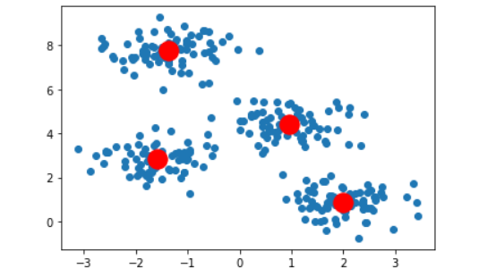

**RESULT:-**

Thus the python program to implement K-Means model has been successfully implemented and the results have been verified and analyzed.